Busy QA

Carlos instructor

Master degree

Lisa

Computer engineering. Java developer 1 year.

Mckanna

Front end developer

Jinn

Graphic designer. Video, banners, etc.

Paal

Java backend developer

Erwinn

Philipeans.

What does “full stack” mean? Stack means software. A group of programs/software that work together. Various technologies and frameworks

Front end:

Browser side:

Html, jquery, angular, css, javasript, bootstrap, react, vue, typescript

Back end side:

Backend: oracle, java, spring, hibernated, tomcat, linux, maven, gradle, git, theymeleafhh

Server

Json, webserver

On resume, can mention typescript, bootstrap

Servlets and jsp are obsolete technologies that aren’t used anymore.

Springboot is a minimal configuration module of spring. It saves a lot of the configuration work. You need to know how springboot works so that you know if its doing what you want it to do.

Hibernate is a framework. It is devoted to database connections.

Maven and gradle are tools that we use to help build our project. Helps to package the project and the libraries.

In the past you had this server tower that had networks connecting. And maybe a server connecting to the database. Normally you’d have two different servers to balance the load. This was the approach in the 1990’s. In the 1990s including installation, a server might cost something around $10,000 - $40,000usd. And then after 3 years they’d get slow and not able to handle all the transactions. The problem was that the servers only ran 12 processors and there wasn’t room to add more processors. So now you’d need to buy more servers. So now you need a server that can hold 32 processors. This one would now cost $60,000usd and then you’d need to find someone who was willing to buy your old server.

Then amazon came along and started renting out space in their server for you. Now there’s also google, IBM, azure who are providers. But it used to just be amazon.

Docker and Kubernetes are used to monitor your software in the cloud to check that its still running and not crashing. Other software out there too.

Studying:

4 hours of java of studying a week.

Spring: need to study 6 hours a week

14 weeks starting from next week. 12-4pm

Week 1:

Diagram.

On the browser side, we’re going to use angular, html, css

On the server side, we’re using java, spring, springboot, hibernate, tomcat, database

Java development kit: tools for developing.

JVM: java virtual machine.

Operating system runs and protects the hardware.

Java program runs over the java virtual machine.

In 1991, when you coded a program, you needed to code a program for a specific operating system. The java virtual machine allows you to run the program on windows, linux, mac, etc.

So in the 1990s, java came along and they created a java virtual machine layer in between the operating system so that you could run it on any of the operating systems. So when you install JVM, it will ask you if you want to install for windows, mac, linux, etc.

After this came along, all the programming languages started adding in their own virtual machine.

V8 engine is a similar idea. Javascript runs in the engine. But its not exactly the same.

IDE’s are editors. You can use netbeans, eclipse, intellij, etc. These editors are java programs. Runs on the JVM.

In the JDK, you get the JVM, the java compiler, java tools. The java compiler is the most important.

JRE: java runtime environment. So you have the option between installing a JRE or the JDK. JRE just allows you to run java programs (for users), JDK gives you development tools

Tomcat is written in java and runs on the JVM.

3 types of java

Java standard edition (SE)

Java enterprise edition (EE)

Java micro edition (ME)

If you see a job posteing that mentions J2EE, or J2SE, now you know the differences.

When you install JRE, you’re installing Java SE. So you have the main libraries such as variables, main data structures. Mostly to build desktop applications.

When you use the JRE or the JDK, you’re using the Java SE.

When you use Java EE, that means that you’re using it for web applications. Libraries for sending and receiving requests. Java libraries, related to networks. So now you need to install tomcat. So tomcat includes the enterprise edition libraries.

Java ME is when you’re using java for coding mobile devices. Smaller devices that don’t have as many resources as a server. So you have a small version of the JVM. Reduced version.

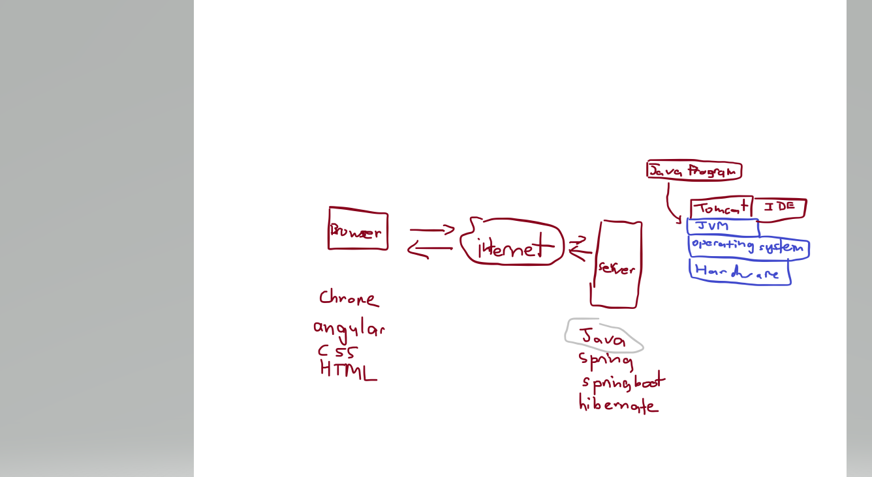

When java was created, it was made by James Gosling who worked for Sun microsystems. The goal was to create a programming language for appliances. Ex. Refridgeraters that were using programs. Wanted to make a system that could run on any platform independently of the operating system.

In 1995 or 1996, java was released for that community. This version of java was called javea 1.0

In 1998 they released java 2. More general purpose. Huge transformation. So that’s why they added the number 2. So if you see J2EE, that’s where the 2 comes from.

They could have called it java 1.2, but they chose to call it java 2

Then they released java 1.3, 1.4, 1.5, 1.6, 1.7, 1.8, 1.9, 1.10, 1.11… They then decided to remove the 2 from the name. So they now just call it java EE and Java SE. If you see J2EE, that means they’re not aware that they naming convention has changed.

Variables are portions of memory that we’re going to store information

In the hardware, we have

ROM memory.

RAM memory. Means that you can access any part of it using a memory address.

Stoarage hard disk.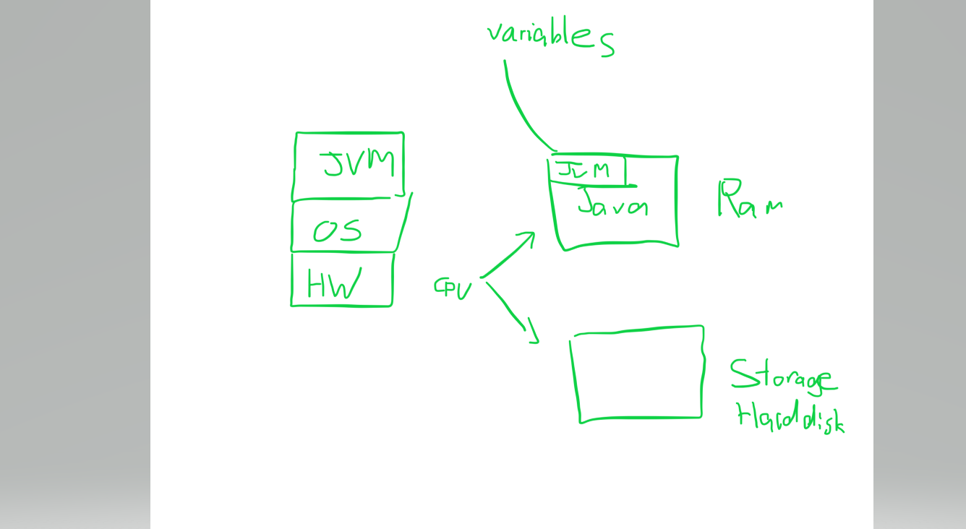

Jar files means:

JAR: Jave archive resource

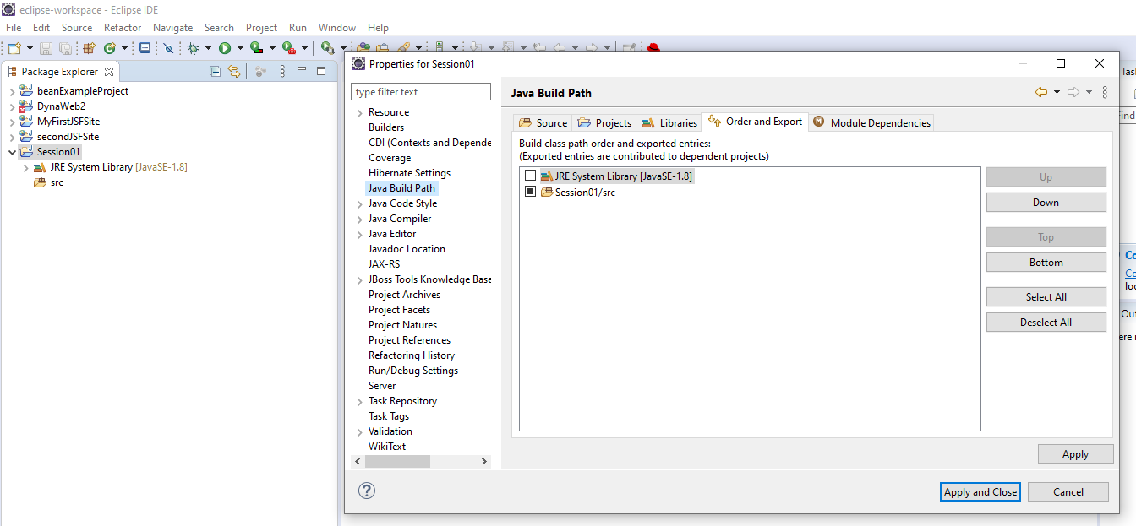

In the properties -> buildpath it allows you to add your libraries.

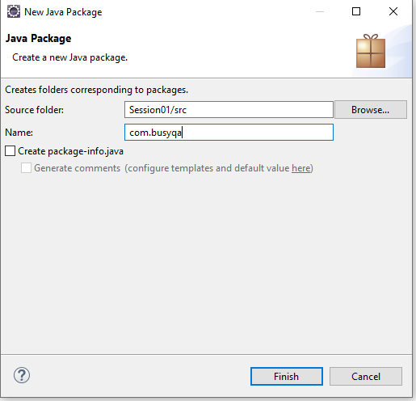

By convention, we use the reverse of the url. So intead of busyqa.com, they use com.busyqa.course

This way you get to guarantee that the projects will never have the same name. So the way to differentiate between companies and projects is to use the company name, then the project, and so on…

The packages are used to differentiate files.

Packages are just folders

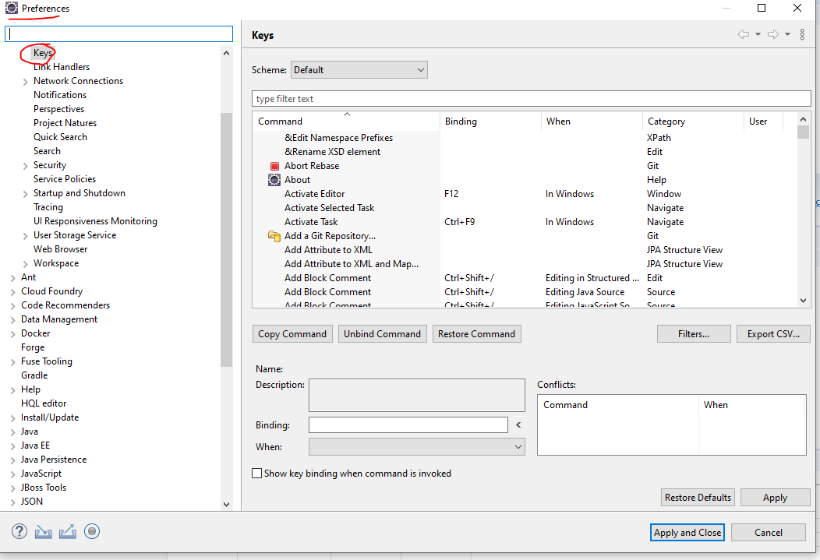

You can configure your shortcuts

Ctrl + alt + down on some computers lets you copy and paste underneath.

But on some computers you like mine you’ll need to set up different keys to do this.

When you run the program, it will create a new JVM and show the results in the console. So you’ll see a short waiting scene. Behind the scene, its creating the JVM. The code needs to be converted into byte code. Byte code is code that is run over the JVM.

Byte code meaning pseudo computer code. Its still not 1’s and 0’s though. That’s actual computer code.

If you were to look in the bin folder, you can find the binary code for your project. The byte code is what is executed on the JVM. Its not the java class code that’s executed, it’s the byte code.

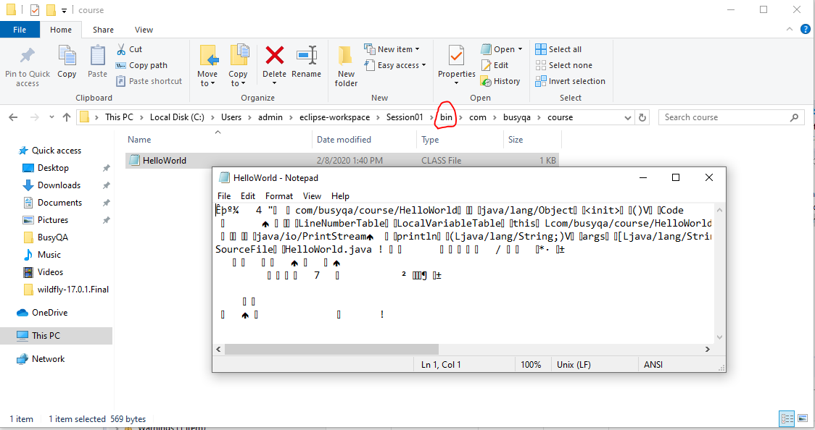

00000000 0-255

11111111

Ram assuming only positive numbers.

But with ints, we positive and negative. So from -127 to 128. So the first byte is used for the positive/negative sign.

ASCII: American standard coding characters of the English language. Goes from 0-255. So we shifted from ASCII to Unicode which is the coding for all the characters that enables it to incorporate all the other languages too.

UTF8 is a way of codifying for English. Its another sort of codifying.

**Java has two types of variables:**

Primitives:

int, float, double, char, byte, short, long

Class types:

Integer, Float, Double, Character, Byte, Short, Long, String

Notice the difference between them. And that String is only in the class side. In python, you’d only find the class types and not the primitive types. Primitive types were created in java 1. In order to maintain backwards compatibility, they kept the primitive types. But now days you should just use the class types.

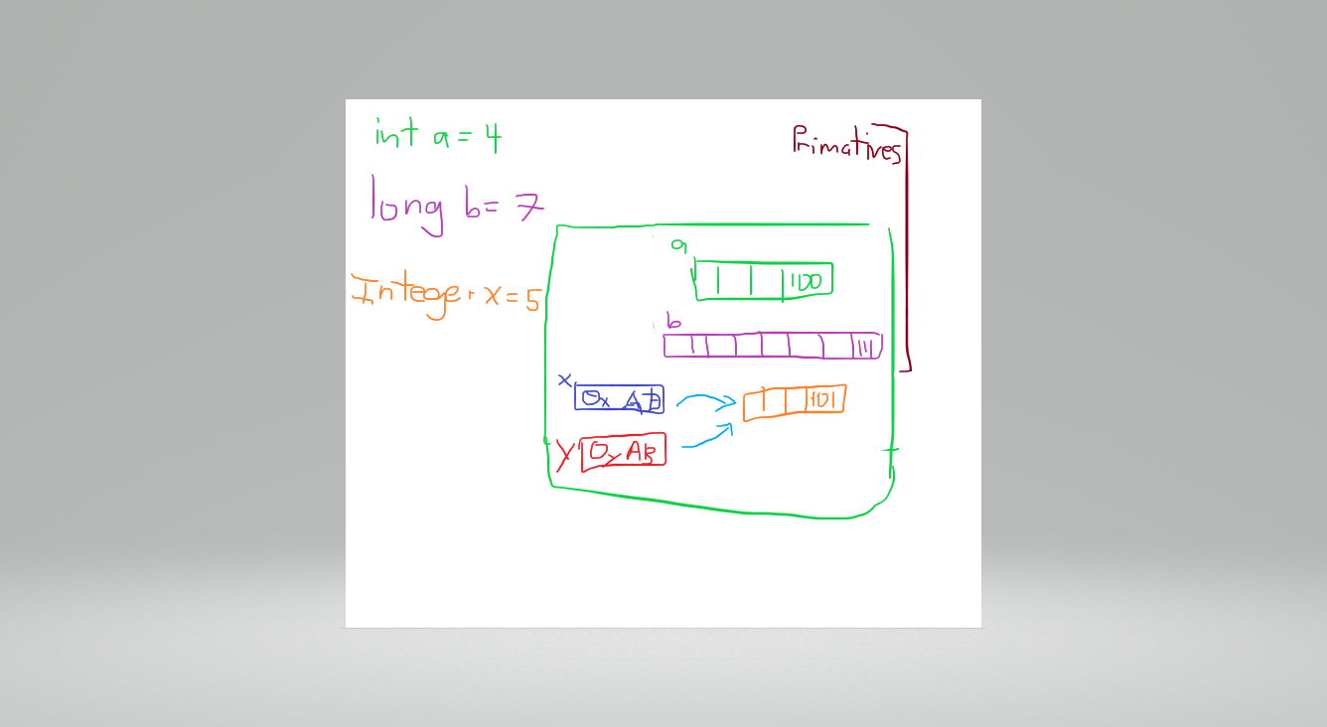

When you are using the primitives, you just have a place in memory for the primatives.

When you are using classes though, it has two places in memory now. One for the value, and one containing the object with an address to the value in memory. So it allocates two different places in memory. Now in the future, whenever it wants to use that value, it doesn’t have to create another value in memory, it can simply point to the same address in memory.

Once you have created a Class type, it is immutable/ protected and can’t be changed into another type.

So the takeaway is that if you make something equal to a class type, realize that they point to the same place in memory. So if you overwrite one class that is equal to another class, then you might be overwriting.

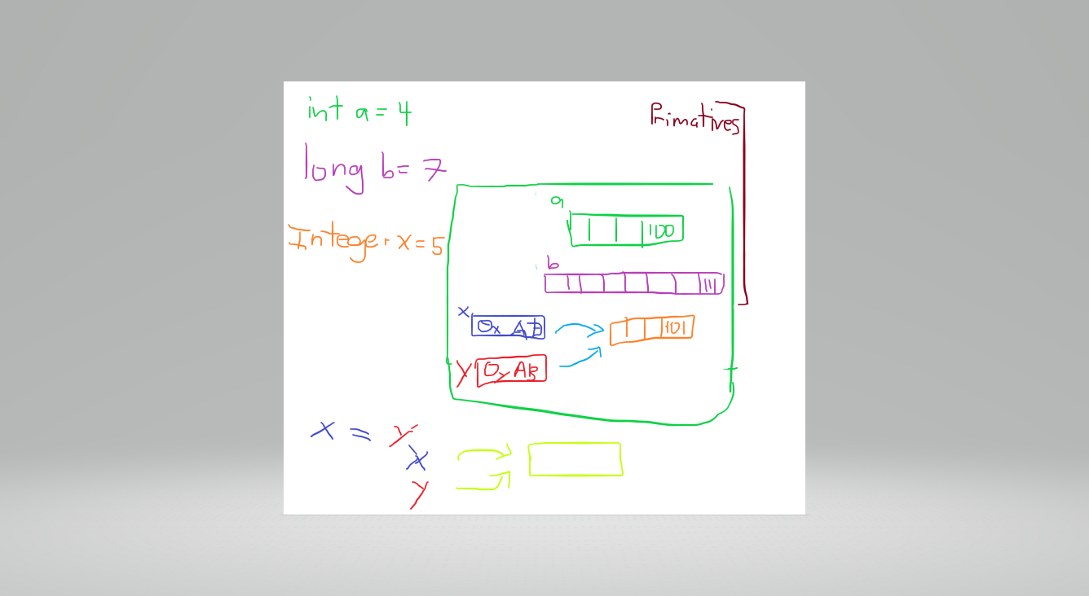

Especially when you start to play around with Strings, you might suddenly discover that your Strings are pointing to the same place as another String, so they are getting overwritten. So you need to be careful that you might have two classes that are pointing to the same data in memory. Avoid overriding. Might be safer to allocate memory for each.

Week2:

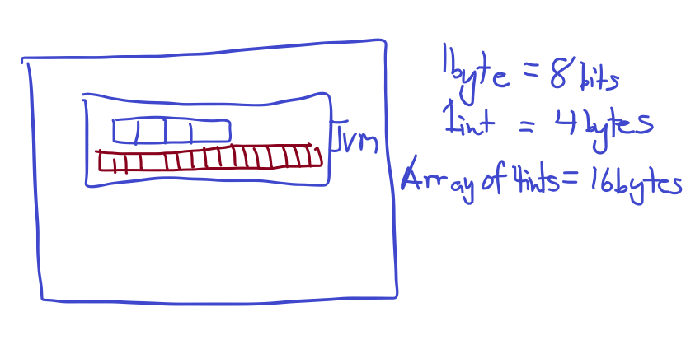

Arrays have an index that start with 0.

Arrays need to be the same type of element. Python is different. Javascript too?

What’s the difference between a java project and a gradle project?

Historically there was only java projects. A few years ago, a few building tools were invented. In a java project, if you want to include libraries, you have to do so manually. And you need to configure the library including the version, include the library, reference it in the build path, add the library jar files manually. In a large project, this is very tedious. You might have 100 – 200 libraries. And all the libraries need to be compatible with eachother. And when you update one library, maybe now some of the libraries are not compatible.

Ant building tool came along that was a java building tool that helped to build your project.

Maven then came along that was used to help build the project using XML building tools.

Gradle is the evolution of maven. Maven required using text files.

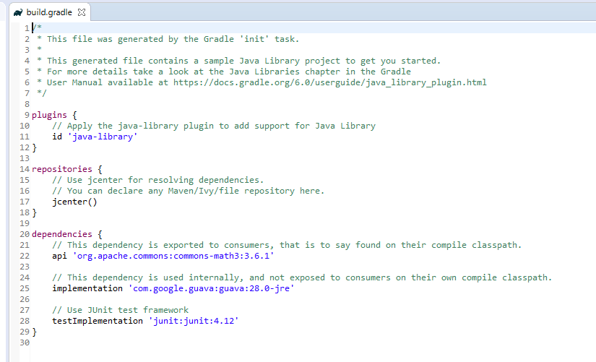

So in this gradle file, if you need to use a different version, you just update it in the gradle file.

Some things you can do in gradle:

-every time you want to deploy your project, you can tell gradle to run the unit tests first.

Sonar is a tool that helps you to verify the quality of your code. Givess you some statistics about your code. Automates the building of your project.

This whole process of deploying and automating the building and testing is called “Continuous Integration”. Might see this known as “CI” tools. Known as DevOps tools.

In the past, we code the project, then we create the jar, then we pass the jar to someone else in the company. Who then puts the jar into ther server, provide the libraries. But sometimes integrating several things caused some problems. DevOps is there to improve the communication. But with CI, you can just have one thing that takes care of everything.

You have a development environment, a testing environment, and then the production environment.

Using a plain old java project, you can’t do CI, because you can’t automate the building of the project, the automating of the unit tests, etc.

Maven is a bit older than gradle. It has some more libraries than gradle. The people who once made maven are now the people who are now building gradle.

Inheritance is the mechanism that objects acquire all the properties and behaviors of the parent object.

Encapsulation: what binds code and data together. The variables of a class become hidden from other classes and can only be accessed through the methods of their classes instead of directly.

Polymorphism: ability of a variable, function, or object to take on multiple forms.

Abstraction: hiding implementation details from the user and only providing the functionality to the user. Using interfaces and abstract classes. The interface allows us to hide the implementation.

So 4:

Inheritance, polymorphism, encapsulation, abstraction. They belong not to java, but to object oriented programming. So any object oriented programming uses these concepts. Python and ruby also have these concepts.

Zoom It software can be used to zoom in.

Instead of creating getters and setters, you could alternatively just use the Lombok annotation

You can interact with object variables through variable reference, methods, or through constructors

Discussion about constructors. Overloading constructors.

When you use the word “this”, you are referring to the instance variable.

Constructors don’t even have the word void. Java knows that this is a constructor.

Can you overload the main method? Yes. But the jVM will only call the main method that takes (String[] args]

Static means that the method belongs to the class, not to the object instance.

Overriding is when you have an inheritance and you override the method that you inherited.

Final variable. In the main, it can be defined without initializing. But in an object, you must initialize it.